Setup 3 nodes k8s cluster,1 master and 2 node machines:
======================================================
1) launch 3 instances of type t2.medium
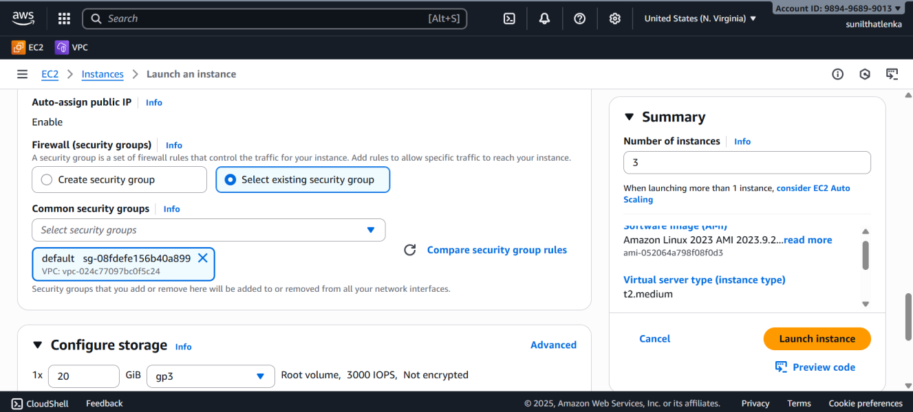
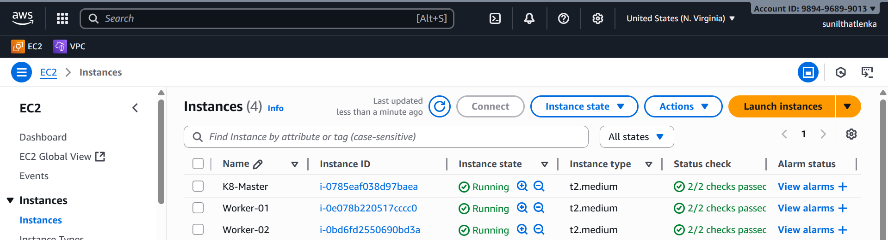
2) Change the hostname
vi /etc/hostname
hostname master
similarly do it workers hostnames
hostname worker-01
hostname worker -02
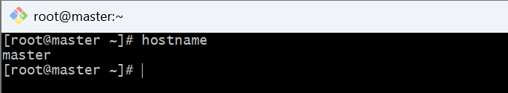

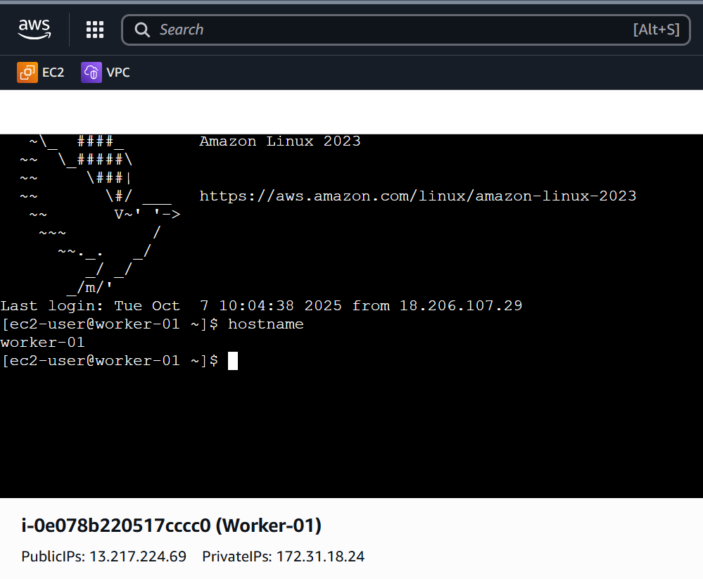
3) Install docker on all 3 instances
yum -y install docker

systemctl start docker
systemctl enable docker
systemctl status docker

4) To setup k8s cluster we have different tools like kops and kubeadm.
[Do the same in workers nodes as well]

https://kubernetes.io/docs/setup/production-environment/tools/kubeadm/install-kubeadm/

# This overwrites any existing configuration in /etc/yum.repos.d/kubernetes.repo
cat <<EOF | sudo tee /etc/yum.repos.d/kubernetes.repo
[kubernetes]
name=Kubernetes
baseurl=https://pkgs.k8s.io/core:/stable:/v1.34/rpm/
enabled=1
gpgcheck=1
gpgkey=https://pkgs.k8s.io/core:/stable:/v1.34/rpm/repodata/repomd.xml.key
exclude=kubelet kubeadm kubectl cri-tools kubernetes-cni
EOF
5) [Do the same in workers nodes as well]

sudo yum install -y kubelet kubeadm kubectl --disableexcludes=kubernetes
sudo systemctl enable --now kubelet

6) TO configure master we need to initialize with CIDR

[install only in the Master node]

kubeadm init --pod-network-cidr=10.244.0.0/16

it will generate this

kubeadm join 172.31.5.28:6443 --token m1oimk.id30foo7chnvp2m4 \
--discovery-token-ca-cert-hash sha256:abd06fbdbfa1a3d2a5fb40b98532af421988649d6a65b5d1bfd1e6d696c52967

7) [install only in the Master node]

mkdir -p $HOME/.kube
sudo cp -i /etc/kubernetes/admin.conf $HOME/.kube/config
sudo chown $(id -u):$(id -g) $HOME/.kube/config

8) Now copy the token and execute on worker machines.

[Copy the above generated token in the 6 th step and copy in only worker machines]

kubeadm join 172.31.5.28:6443 --token m1oimk.id30foo7chnvp2m4 \
--discovery-token-ca-cert-hash sha256:abd06fbdbfa1a3d2a5fb40b98532af421988649d6a65b5d1bfd1e6d696c52967
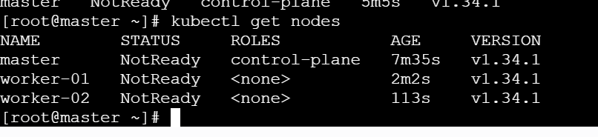

9) Install Flannel and check the status of nodes

[only in master]

kubectl apply -f https://github.com/flannel-io/flannel/releases/latest/download/kube-flannel.yml

